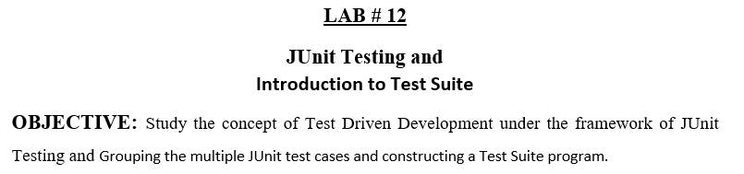

**Lab Task:**

* Add another test case for countA function (which is given in code).

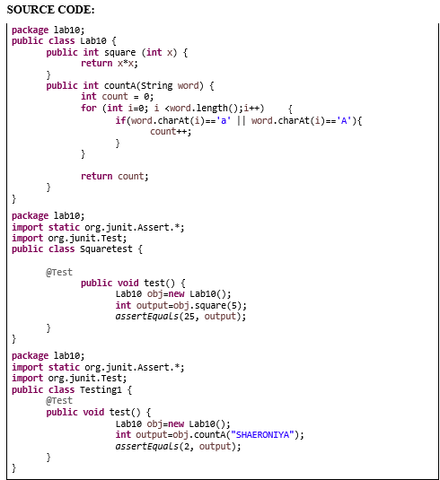

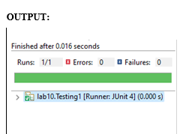

* Make new project, make a class. Add 2 methods in it. One method will find the max integer present in the input integer array. The other method will find the min integer. Now create test cases for both these methods and test your code. Follow all the steps as mentioned above in the manual.

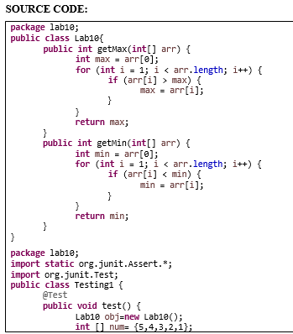

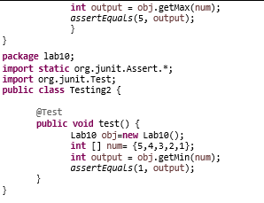

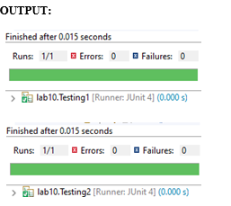

* Make a class having four functions for determining,

* Whether the input integer is odd. * Whether the input integer is even. * Whether the input integer is prime.

* For calculating the factorial of that input integer.

Write their test cases and execute them in a single test suite class. Follow all the steps mentionedabove in the manual.

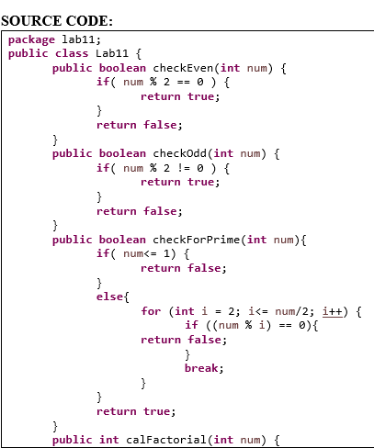

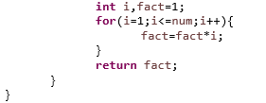

**EVEN NUMBER:**

**package** lab11;

**import static** org.junit.Assert.*;

**import** org.junit.Test;

**public class** EvenNo {

@Test

**public void** test() {

Lab11 obj=**new** Lab11();

**boolean** output=obj.checkEven(2);

*assertEquals*(**true**,output);

}

}

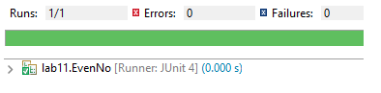

**ODD NUMBER:**

**package** lab11;

**import static** org.junit.Assert.*;

**import** org.junit.Test;

**public class** OddNo {

@Test

**public void** test() {

Lab11 obj=**new** Lab11();

**boolean** output=obj.checkOdd(3); *assertEquals*(**true**,output);

}

}

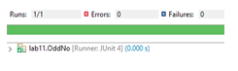

**FACTORIAL:**

**package** lab11;

**import static** org.junit.Assert.*;

**import** org.junit.Test;

**public class** Factorial { @Test

**public void** test() {

Lab11 obj=**new** Lab11();

**int** output=obj.calFactorial(5);

*assertEquals*(120,output);

}

}



**PRIME NUMBER:**

**package** lab11;

**import static** org.junit.Assert.*;

**import** org.junit.Test;

**public class** PrimeNo { @Test

**public void** test() {

Lab11 obj=**new** Lab11();

**boolean** output=obj.checkForPrime(5);

*assertEquals*(**true**,output);

}

}

  
**SUITE CLASS:**

**package** lab11;

**import** org.junit.runner.RunWith;

**import** org.junit.runners.Suite;

**import** org.junit.runners.Suite.SuiteClasses; @RunWith(Suite.**class**)

@SuiteClasses({ EvenNo.**class**, Factorial.**class**, OddNo.**class**, PrimeNo.**class** })

**public class** AllTests {

}

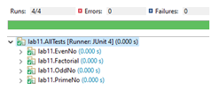

Git hub: